## A.1 Individual Inspection 1

|  |  |  |  |  |
| --- | --- | --- | --- | --- |
| **Inspector:** Luca Leoni | | | | |
| **Heuristic Type** | **Heuristic** | **Score** | **Comment** | **Reference** |
| Nielsen | Visibility of system status | 1 | Despite the website retains the information about the status, the breadcrumb is badly implemented. The user is not aware of the presence of it. Indeed, it is not clearly shown as a status bar. A kind of Location-Based Breadcrumb is implemented, but not in an intuitive way. | Screenshot 1. 1 |



Screenshot 1. 1 <https://www.reply.com/en/industries/logistics-and-manufacturing/>

|  |  |  |  |  |
| --- | --- | --- | --- | --- |
| **Heuristic Type** | **Heuristic** | **Score** | **Comment** | **Reference** |
| Nielsen | Match between system and the real world | 4 | The only problem is related to the partial translation of the principal labels. In fact, the main labels are only in English, so, they could not appear natural and logical to the users. | Screenshot 1. 2 |



Screenshot 1. 2 <https://www.reply.com>

|  |  |  |  |  |
| --- | --- | --- | --- | --- |
| **Heuristic Type** | **Heuristic** | **Score** | **Comment** | **Reference** |
| Nielsen | User control and freedom | 4 | In the majority of the cases, you can at most perform 3 steps. From the Homepage to a specific showcase (you can go back through the x button) and from there to a specific page. In this case, we have to differentiate the case in which a new panel is opened and the case in which appears a window.  PANEL: you can go back simply by closing the panel.  WINDOW: an x button will show and through that you can return to the previous page. | - |
| Nielsen | Consistency and standards | 5 | The essential standards are respected, such as the login button, search box, exit button and share icons. | Screenshot 1. 3 |

Screenshot 1. 3 <https://www.reply.com/en/blockchain>

|  |  |  |  |  |
| --- | --- | --- | --- | --- |
| **Heuristic Type** | **Heuristic** | **Score** | **Comment** | **Reference** |
| Nielsen | Error prevention | 3 | The system presents some weaknesses. For instance, when a new user performs the Registration process, only after confirming the request, the system checks if the rules concerning password or email are followed. | Screenshot 1. 4 |

Screenshot 1. 4 <https://www.reply.com/en/register>

|  |  |  |  |  |
| --- | --- | --- | --- | --- |
| **Heuristic Type** | **Heuristic** | **Score** | **Comment** | **Reference** |
| Nielsen | Recognition rather than recall | 2 | The system does not provide any suggestions when a user tries to search for something. Despite that, in the Webinar section, it has been implemented a live filtering search box (every time the user types a letter, the system checks and shows only the matching results). | Screenshot 1. 5 |

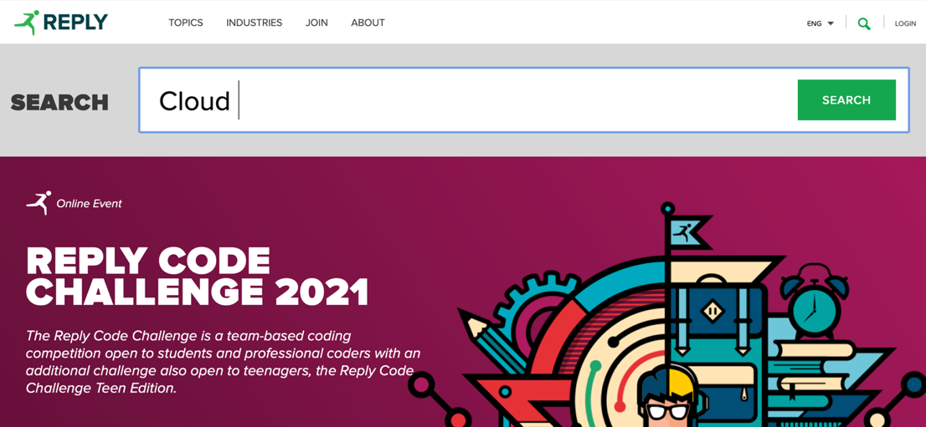

Screenshot 1. 5 <https://www.reply.com>

|  |  |  |  |  |
| --- | --- | --- | --- | --- |
| **Heuristic Type** | **Heuristic** | **Score** | **Comment** | **Reference** |
| Nielsen | Flexibility and efficiency of use | 4 | The navigation through the header is not helpful. Indeed, there are too many categories and the users could be disoriented. | - |
| Nielsen | Aesthetic and minimalist design | 0 | The whole website is crowded with information. There are too many subcategories in each section. The Homepage acts as a showcase with all the articles of the website. Despite that, the aesthetic is good. | Screenshot 1. 6 |

Screenshot 1. 6 <https://www.reply.com>

|  |  |  |  |  |
| --- | --- | --- | --- | --- |
| **Heuristic Type** | **Heuristic** | **Score** | **Comment** | **Reference** |
| Nielsen | Help users recognize, diagnose and recover from errors | 1 | The heuristic is not satisfied in several cases. If a user searches through the search box and commits a typo the system is able to detect it, but it does not show the correct answers. Also, in the Webinar section happens the same. Furthermore, during the login process, if a user writes the wrong email or password, the system notifies the user with a generic error message. | Screenshot 1. 7  Screenshot 1. 8 |

Screenshot 1. 7 [https://www.reply.com/en/login](https://stscorp.reply.com/adfs/ls/?wa=wsignin1.0&wtrealm=urn%3areplyeu%3awww&wctx=https%3a%2f%2fwww.reply.com%2fen%2f_layouts%2f15%2fAuthenticate.aspx%3fSource%3d%252Fen%252Fblockchain)

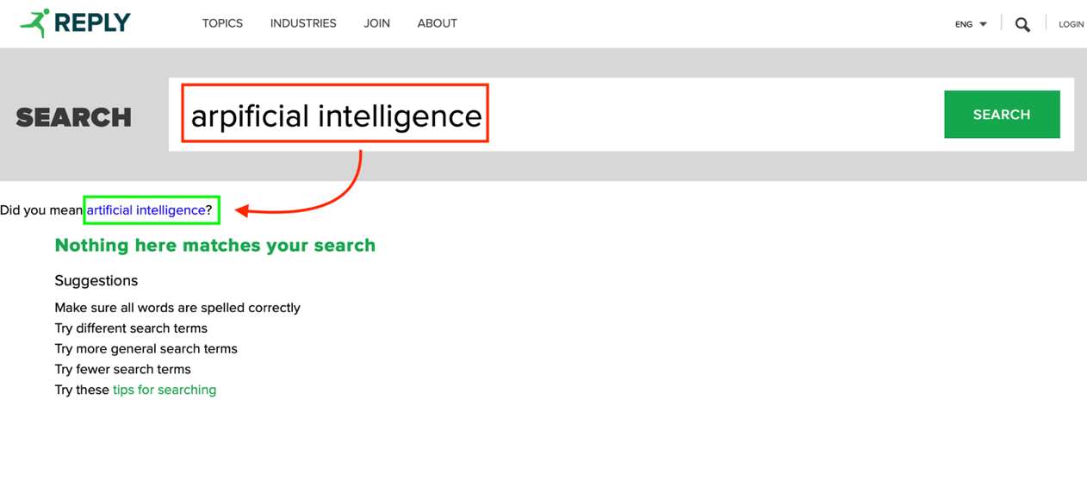

Screenshot 1. 8 <https://www.reply.com/en/search?k=arpificial%20intelligence>

|  |  |  |  |  |
| --- | --- | --- | --- | --- |
| **Heuristic Type** | **Heuristic** | **Score** | **Comment** | **Reference** |
| Nielsen | Help and documentation | N/A | - | - |
| MILE Navigation | Interaction consistency | 5 | The steps to be followed are always the same. | - |
| MILE Navigation | Group navigation | 0 | The flow is not stable. Indeed, due to the leak of breadcrumb, the user cannot navigate through the different pages without restarting from scratch. | Screenshot 1. 9 |

Screenshot 1. 9 <https://www.reply.com/en/industries/retail-and-consumer-products/>

|  |  |  |  |  |
| --- | --- | --- | --- | --- |
| **Heuristic Type** | **Heuristic** | **Score** | **Comment** | **Reference** |
| MILE Navigation | Structural Navigation | 3 | The website presents too many components. Despite that, it is simple to explore all the parts of a topic since they are all displayed on a single page. | - |
| MILE Navigation | Semantic Navigation | 4 | Sometimes N/A. When applicable, the articles are displayed, joined with related posts. | - |
| MILE Navigation | Landmarks | 4 | The landmarks are always available. Despite that, they are full of information and sometimes the user does not know in advance exactly where he has to go to find information. | - |
| MILE Content | Information overload | 0 | The Homepage is full of information. It contains all the articles posted on the website. | Screenshot 1. 10 |

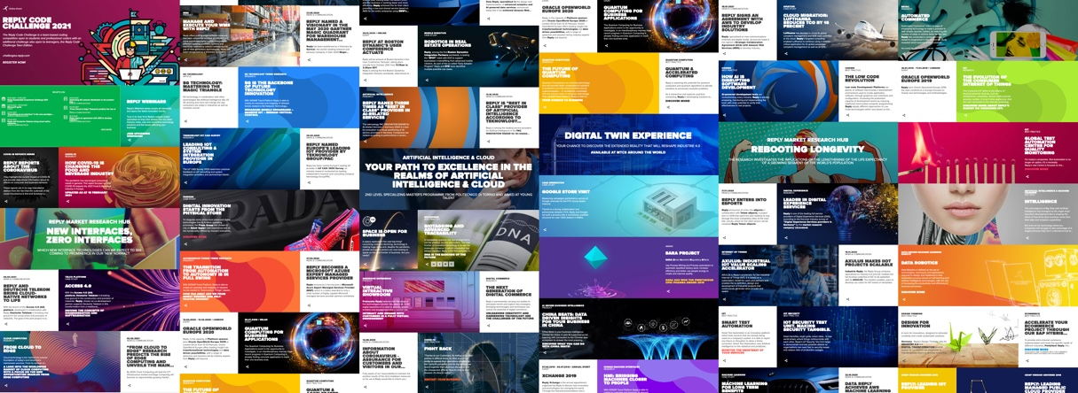

Screenshot 1. 10 <https://www.reply.com>

|  |  |  |  |  |
| --- | --- | --- | --- | --- |
| **Heuristic Type** | **Heuristic** | **Score** | **Comment** | **Reference** |
| MILE Presentation | Text layout | 5 | Despite that in many cases the website uses an image as a background, the text is readable. | Screenshot 1. 11 |



Screenshot 1. 11 <https://www.reply.com/en/topics/supply-chain-management/>

|  |  |  |  |  |
| --- | --- | --- | --- | --- |
| **Heuristic Type** | **Heuristic** | **Score** | **Comment** | **Reference** |
| MILE Presentation | Interaction placeholders-semiotics | 5 | The main icons follow the standard design. E.g., Login button, Search function, Share contents | - |
| MILE Presentation | Interaction placeholders-consistency | 5 | On each page, the placeholders are available in the same position and with the same aspect. | - |
| MILE Presentation | Spatial allocation | 5 | The pages have all the same structure: header, body and footer. Notice that, sometimes the pages are too long, due to information overload. | - |
| MILE Presentation | Consistency of Page Structure | 4 | The heuristic is not satisfied in some cases. Indeed, sometimes a new page appears as a pop-up window, while sometimes it is opened in a new panel. | Screenshot 1. 12 |

Screenshot 1. 12: <https://www.reply.com/en/topics/ecommerce/>